The plan for my game has shifted a bit and I am now giving up on creating an experience with nice environments, and instead creating an experience wandering through a more simple area, collecting notes to clear the level. I will be using ProBuilder to create the majority of worlds and using the default texture applied to them as they don’t look bad and remind me of Portal. This will also make sure that I am well above the 50% originality requirement. The player movement will still be teleporting using the LaserTeleport script provided in class.

To collect the notes, I have created a prefab with a mesh collider and box collider to detect when the Player collides with it. I have also added a yellow spotlight to let players know where the notes are located.

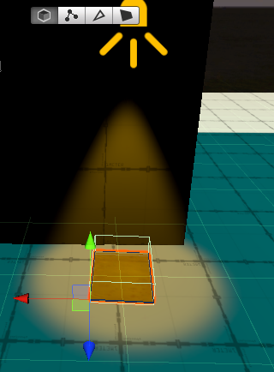

This will then turn off the MeshRenderer on the note and add a point to the total score. The score activates the exit when 4 notes are collected.

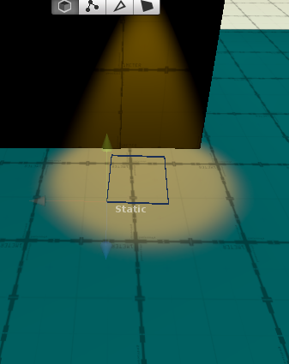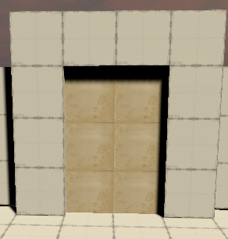

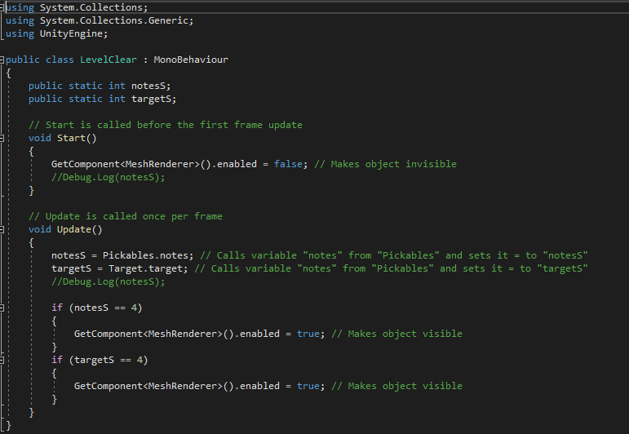

The overall level design is simple and I’ve stated before, only having a few tables in the starting area to add a little to the environment.

